Problemas leyendo archive csv o TXT

No se puede si utiliza 64 bits, debe convertirlo a 32

1. Select Build del menu de arriba

2. Open the Configuration Manager dialog

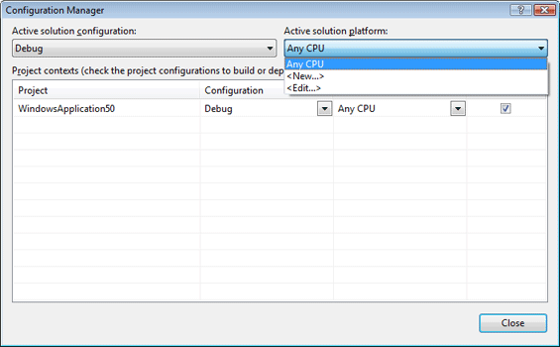

3. Select the <New...>

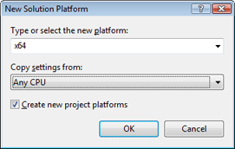

4. Confirm the settings in the dialog by clicking OK. A new configuration for x64 is created.

5. Repeat step 3 and 4 for an x86 configuration. The Active solution platform dropdown box of theConfiguration Manager dialog box should now look like this:

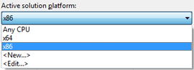

6. Select <Edit...> from the dropdown box to open the edit Solution Platforms dialog.

7. Select Any CPU and click Remove to remove this configuration.

8. Close both dialogs by clicking Close.

The Solution Platform dropdown box of Visual Studio should now look like this:

